Steps to Integrate UI Router with the TwitterApp.

Step1: download the ui.router library and add it to vendor folder.

Step2: Refer the library in the index.html after the angular.min.js

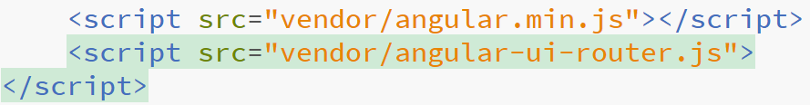

Step3: Refer the ui.router module in the app.js as a dependency.

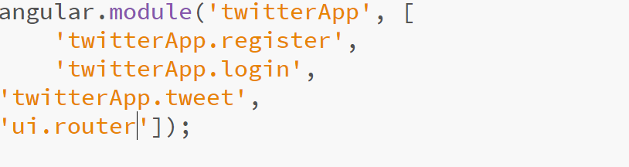

Step4: inject the $stateProvider,$urlRouterProvider to the config function.

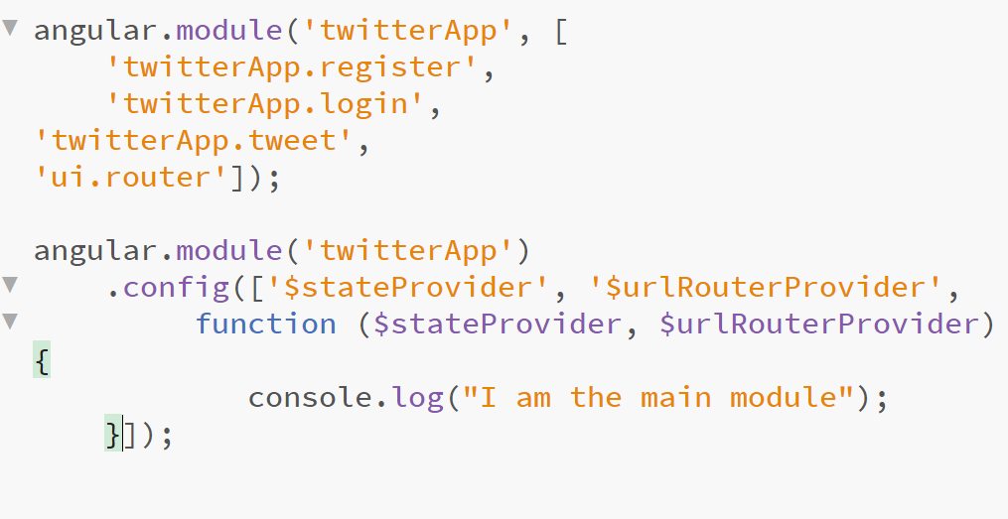

Step6: Define the routes.

Ex:

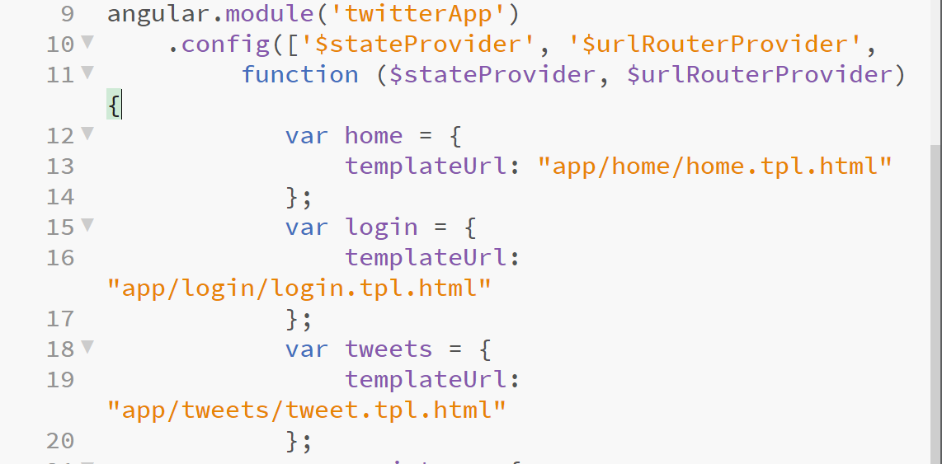

Step7: register the routes.

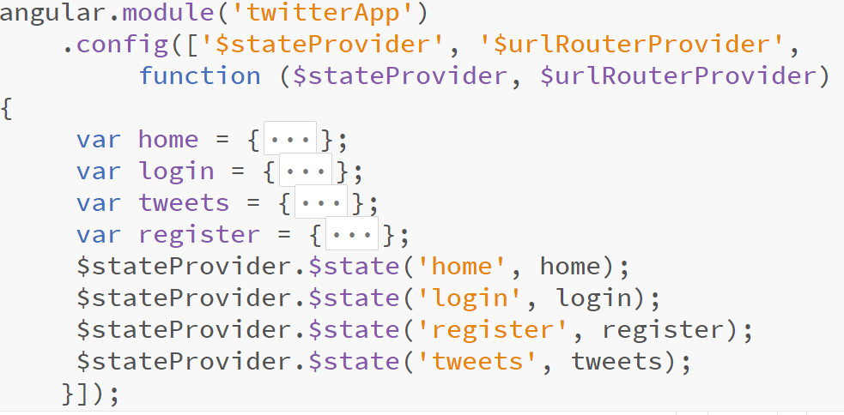

Step 8 : declare the ui-view directive in the index.html

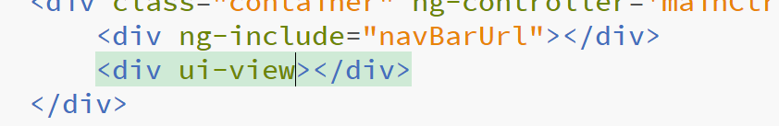

Step-9: Handle the click.

